# Model 1 – moderation1() – Two Way Moderation

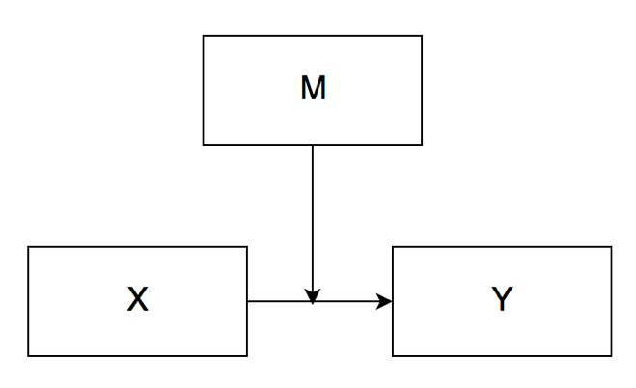

Two-Way Moderation

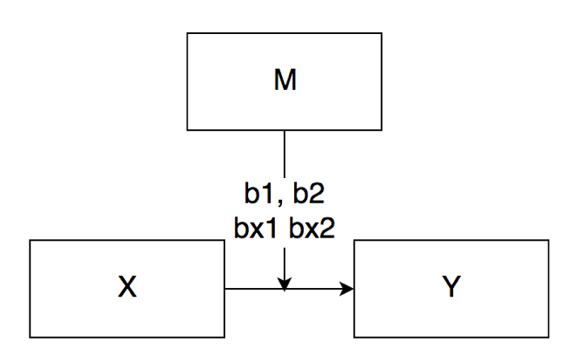

Two-Way Moderation with categorical M

# 

Two-Way Moderation of X*M to Y with two Covariates

# Model 4 – mediation1() – Simple Mediation

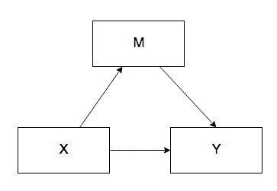

Simple Mediation

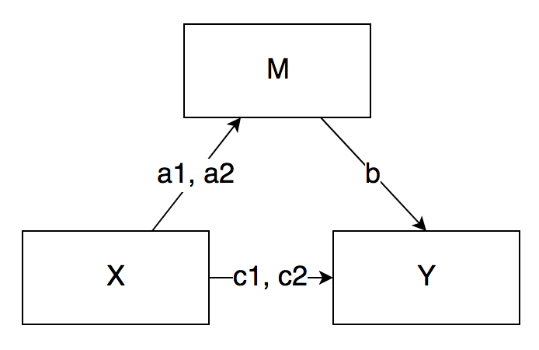

Simple Mediation with categorical X, which has three levels.

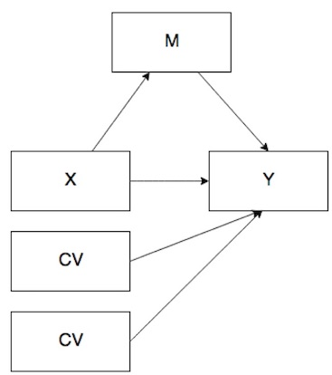

Simple mediation with two covariates, as an example.

# Model 6 – mediation2() – Serial Mediation

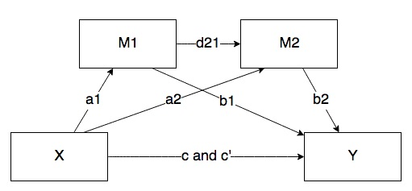

Serial mediation with two mediators

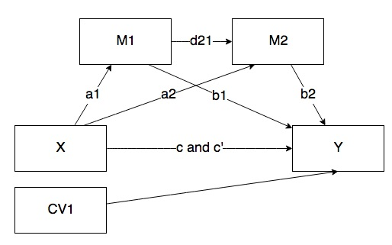

Serial mediation with two mediators and a CV